

**Name :-** Waad Hesham Mohamady

**B.N:-** 12

**ID :-** 1026

**Date**:- 2021/6/11

## Topic :-

**Programming Languages**

Application Brief: -

I've written a description most popular programming languages

such as

1. C++

Web developers commonly learn C++ to gain low-level control of machine resources. Although this level of control may be unnecessary for most web developers, it will prove extremely valuable for performance-critical applications, such as video games.

2. Java

Web-based developers use and learn Java for many reasons, but I will highlight just two of them: mobile development and formal education. The first reason refers to Java's use for building Android-based applications. The second reason relates to Java's adoption in colleges and universities to teach computer science concepts.

3-HTML

is the standard markup language for creating Web pages

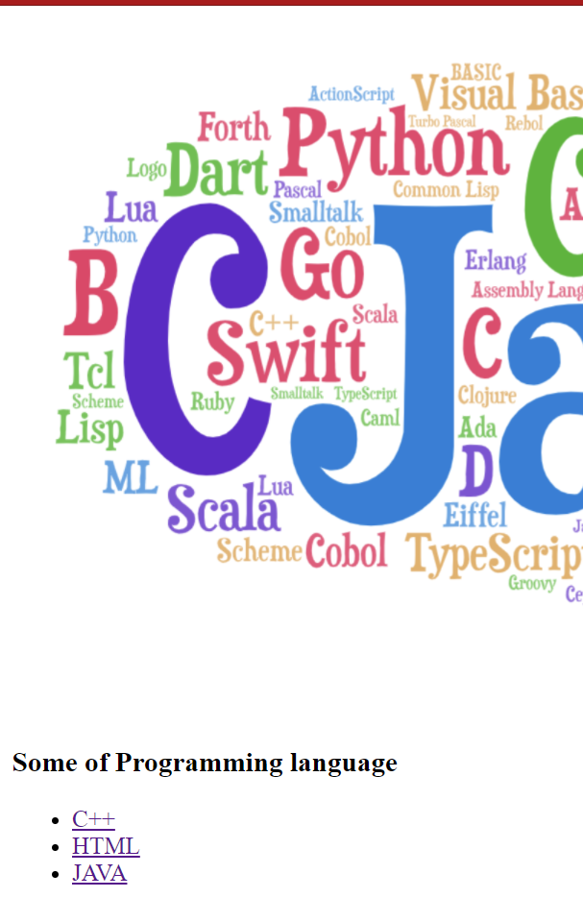

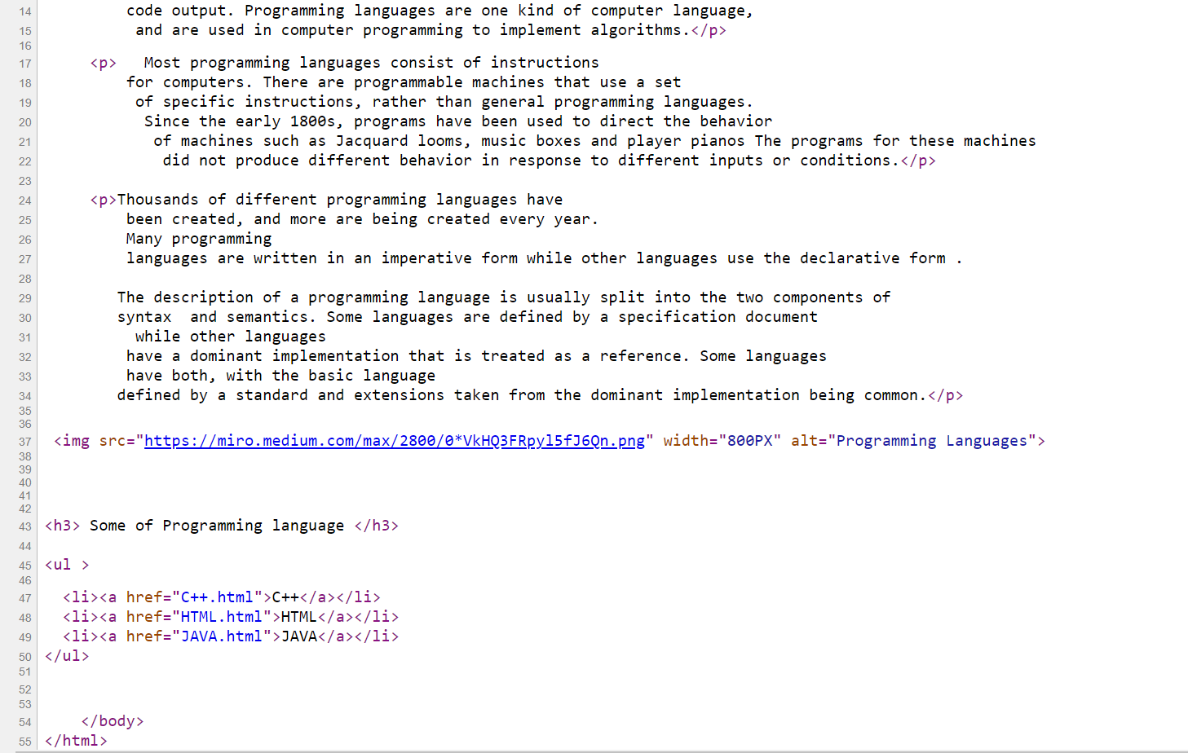**Screenshots: -**

